# **Name: Abdur R. Qureshi**

# **Roll No: 242466**

Assignment No: 2

Date Of Performance: 18/10/2025

Aim: AWS Academy '" Cloud Operations " Badge and certificate, issued by Amazon Web Services



Badge

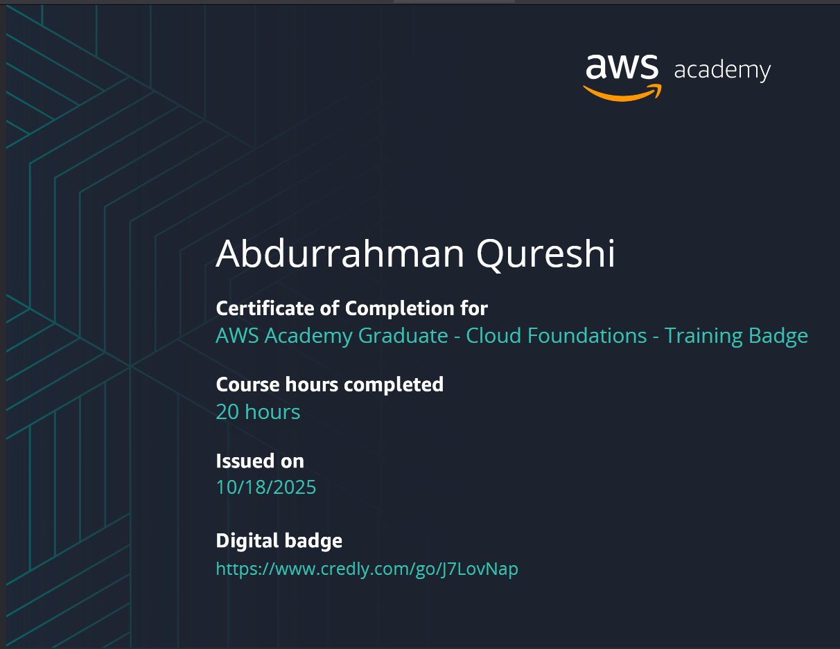

Certificate